**CENWP-OD-D 1/9/2023**

**MEMORANDUM FOR THE RECORD 23TDA1**

**SUBJECT: North Fishladder Mystery Mortality**

On 1/1/23 a salmonid mortality was noticed atop a ledge in the north fishladder during a fishway inspection. The north fishladder was in full operation. Possible causes include river otters leaving prey on ledge or drifted into eddy during higher tailwater after death.

1. Species –Adult Coho
2. Origin –NA
3. Length –NA
4. Marks and tags –NA
5. Marks and Injuries found on carcass –None visible from distance
6. Cause and Time of Death –unknown
7. Future and Preventative Measures –none at this time

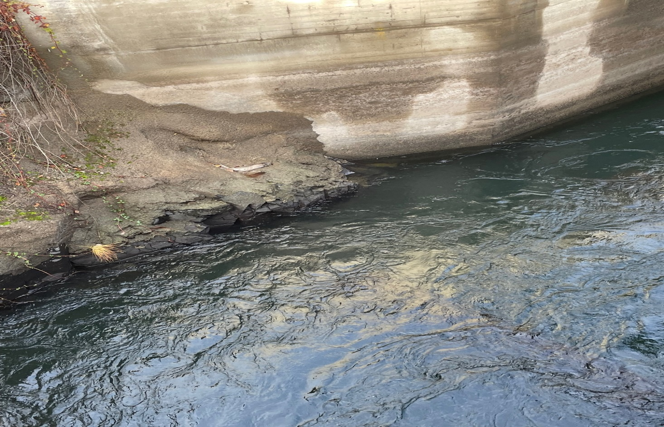

Sincerely,

Project Fisheries